Student Enrollment & Course Management System (SECMS)
User story :
The Student Enrollment & Course Management System (SECMS) is a Salesforce-based application built so that students, enrollment officers, instructors, and administrators can handle the entire enrollment process in one unified platform. As a student, I want to browse available courses, check prerequisites, seat availability, and schedules, and submit my enrollment request online, so that I can register quickly without paperwork or visits to the registrar's office. As an enrollment officer, I want enrollment requests to move through an automated approval process, with the system validating prerequisites, seat capacity, and schedule conflicts, so that I can approve or reject requests accurately and without manual checking. As an instructor, I want to view the students enrolled in my assigned courses and record their attendance and grades, so that I can manage my classes and share results without extra administrative effort. As an administrator, I want to create and manage student records, course offerings, instructor assignments, and payment details, so that the institute's academic data stays accurate and up to date. I also want dashboards and reports on enrollments, course demand, payment status, and instructor workload, so that I can make informed decisions about scheduling, staffing, and resources.

1. INTRODUCTION

1.1 Project Overview :
The Student Enrollment & Course Management System (SECMS) aims to bring all student, course, instructor, and enrollment-related data together in a single Salesforce application, ensuring easy data access, structured workflows, and accurate reporting. The system allows Enrollment Officers to manage student admissions, course registrations, payments, and communication effectively, while instructors and administrators gain full transparency into course offerings, class rosters, and student academic progress. It also supports automated instructor assignment, task creation, validation checks, and multi-level approval processes to keep enrollment management accurate and consistent.
Using Salesforce Flows, Approval Processes, Validation Rules, Reports, and Dashboards, the institute can ensure that every stage of the student journey, from application and admission to course completion, is handled systematically. Validation Rules prevent duplicate enrollments, over-capacity registrations, and incomplete records. Flows automate repetitive tasks such as assigning instructors, sending confirmations, and creating follow-up tasks
1.2 Purpose:
The primary purpose of SECMS is to replace manual and fragmented enrollment processes with a scalable, automated, and secure Salesforce solution that brings speed, accuracy, and transparency to the institute's academic operations. The system ensures:
- Centralized student and course data management: All student profiles, course offerings, instructor details, and enrollment records are stored in one place, reducing duplication and data entry errors.
- Structured enrollment workflows: Every enrollment follows a defined path from application to approval, registration, and course completion, so no request is missed or delayed.
- Automated approvals and validations: Approval Processes and Validation Rules automatically check capacity, duplicate enrollments, and required information, reducing manual verification effort.
- Transparent reporting and monitoring: Reports and Dashboards give administrators and officers real-time visibility into enrollment volume, revenue, student status, and pending approvals.
2. IDEATION PHASE
2.1 Problem Statement (Customer Problem Statement Template)

 |  | But | Because | Which makes me feel
  PS | I  (Customer)
  I'm trying to
 | Manage student enrollments efficiently | Enrollment data is scattered across spreadsheets and emails | Systems are manual and unintegrated | Frustrated and error-prone
  PS-1 | Enrollment Officer
 |  | Reporting is delayed and often inaccurate | Data is not centralized in one platform | Uncertain in decision-making
  PS-2 | Administ
  Track enrollments and revenue
 | View my assigned courses and enrolled students | I don't get updated class rosters on time | Instructor assignments and enrollment changes are communicated manually | Unprepared and disconnecte
  PS-3 | Instructor
 | Register for courses and check my enrollment status | I don't know whether my request is approved or still pending | There is no automated approval tracking or notification system | Anxious and uninformed
  PS-4 | Student

2.2 Empathy Map Canvas
User Persona: Enrollment Officer
- Think & Feel: Worried about double bookings, missed approvals, and revenue loss. Feels pressured to keep records accurate while handling a growing number of requests.
- Hear: Complaints from students about delayed confirmations, and questions from management about pending approvals and enrollment numbers.
- See: Multiple spreadsheets, scattered emails, and paper forms with no single view of enrollment status.
- Say & Do: Rechecks data repeatedly, follows up manually with students and instructors, and updates records by hand.

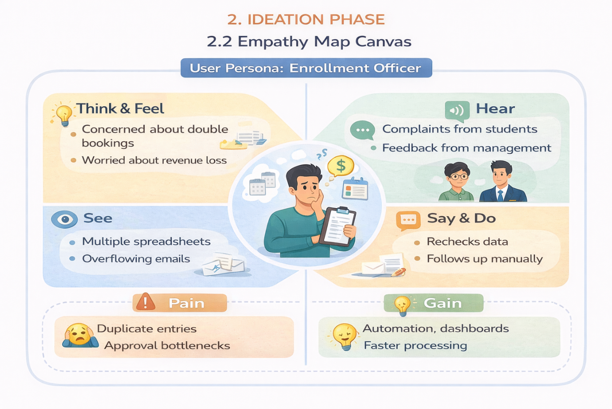

2.3 Brainstorming & Idea Prioritization
Step 1: Brainstormed Ideas
- Spreadsheet automation: Use macros and shared spreadsheets to track students, courses, and enrollments more consistently.
- Standalone enrollment portal: Build a custom web application where students submit enrollment requests online.
- ERP integration: Extend the institute's existing ERP system with enrollment and course management modules.
- Salesforce-based enrollment system: Build a unified cloud application using custom objects, Flows, Approval Processes, Validation Rules, Reports, and Dashboards.
- Automated notifications: Send email confirmations and status updates to students and instructors when a request is approved, rejected, or changed.
- Real-time dashboards: Give administrators live views of enrollment volume, revenue, and pending approvals.

Step 2: Grouping
Group | Ideas | Description
Manual solutions | Spreadsheet automation | Low cost and quick to start, but still depends on manual updates and prone to duplicate entries
Semi-automated solutions | Standalone enrollment portal, ERP integration | Automate parts of the process, but often need separate systems, heavy customization, or complex integration
Fully automated cloud solutions | Salesforce-based enrollment system, automated notifications, real-time dashboards | End-to-end automation of enrollment, approvals, validations, and reporting on one scalable platform

Step 3: Idea Prioritization
Each idea is rated High, Medium, or Low against the criteria below.

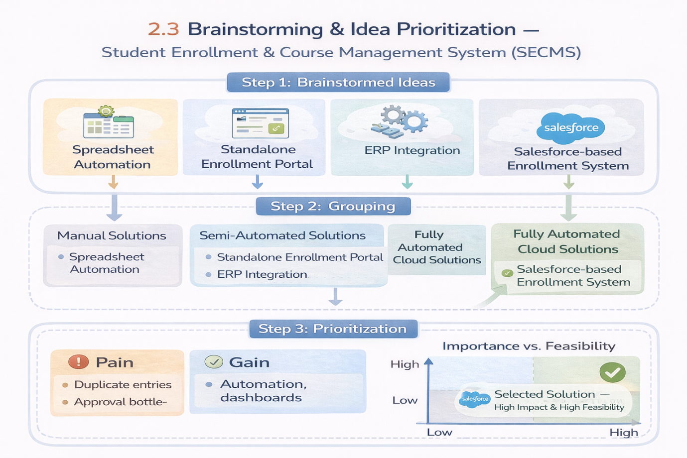
3. REQUIREMENT ANALYSIS PHASE
3.1 Customer Journey Map
The journey map follows a student and the institute staff through the enrollment process, from first contact to course completion.
Stage 1: Awareness & Registration
- User Actions: Learns about the institute and its courses, then registers as a student.
- Touchpoints: Website, brochure, enrollment officer.
- Pain Points: Manual data entry and duplicate student records.
- SECMS Solution: The student record is created in Salesforce, with validation rules that prevent duplicates and incomplete data.
- Emotion: Curious and hopeful.
Stage 2: Course Selection
- User Actions: Browses courses and checks schedules, fees, and seat availability.
- Touchpoints: Course catalog, enrollment officer.
- Pain Points: Outdated course information and unclear seat availability.
- SECMS Solution: A centralized Course object shows capacity, fees, and instructor details.
- Emotion: Interested but unsure.
Stage 3: Enrollment Request
- User Actions: Submits a request for the selected course.
- Touchpoints: Enrollment form, email.
- Pain Points: Paper forms, missed requests, and double bookings.
- SECMS Solution: Each request becomes an Enrollment record, with validation rules that block duplicate and over-capacity enrollments.
- Emotion: Anxious.
Stage 4: Fee Payment
- User Actions: Pays the course fee and shares proof of payment.
- Touchpoints: Payment counter, online payment, enrollment officer.
- Pain Points: Manual payment tracking and delayed confirmation.
- SECMS Solution: A Payment record linked to the enrollment updates the payment status automatically.
- Emotion: Cautious.
Stage 5: Approval
- User Actions: Waits while the request is reviewed and approved.
- Touchpoints: Enrollment officer, administrator.
- Pain Points: Approval bottlenecks and no visibility of status.
- SECMS Solution: A multi-level Approval Process routes requests to the right reviewers and sends automatic notifications.
- Emotion: Impatient and uncertain.
Stage 6: Instructor Assignment
- User Actions: Receives course confirmation while an instructor is assigned to the course.
- Touchpoints: Instructor, administrator.
- Pain Points: Manual assignment and late roster updates.
- SECMS Solution: A Flow assigns the instructor automatically and creates follow-up tasks.
- Emotion: Relieved.
Stage 7: Reporting & Completion
- User Actions: Attends the course and receives results, while management reviews performance.
- Touchpoints: Dashboards, reports, instructor.
- Pain Points: Delayed and inaccurate reporting.
- SECMS Solution: Reports and Dashboards track enrollment volume, revenue, student status, and pending approvals.
- Emotion: Satisfied and confident.

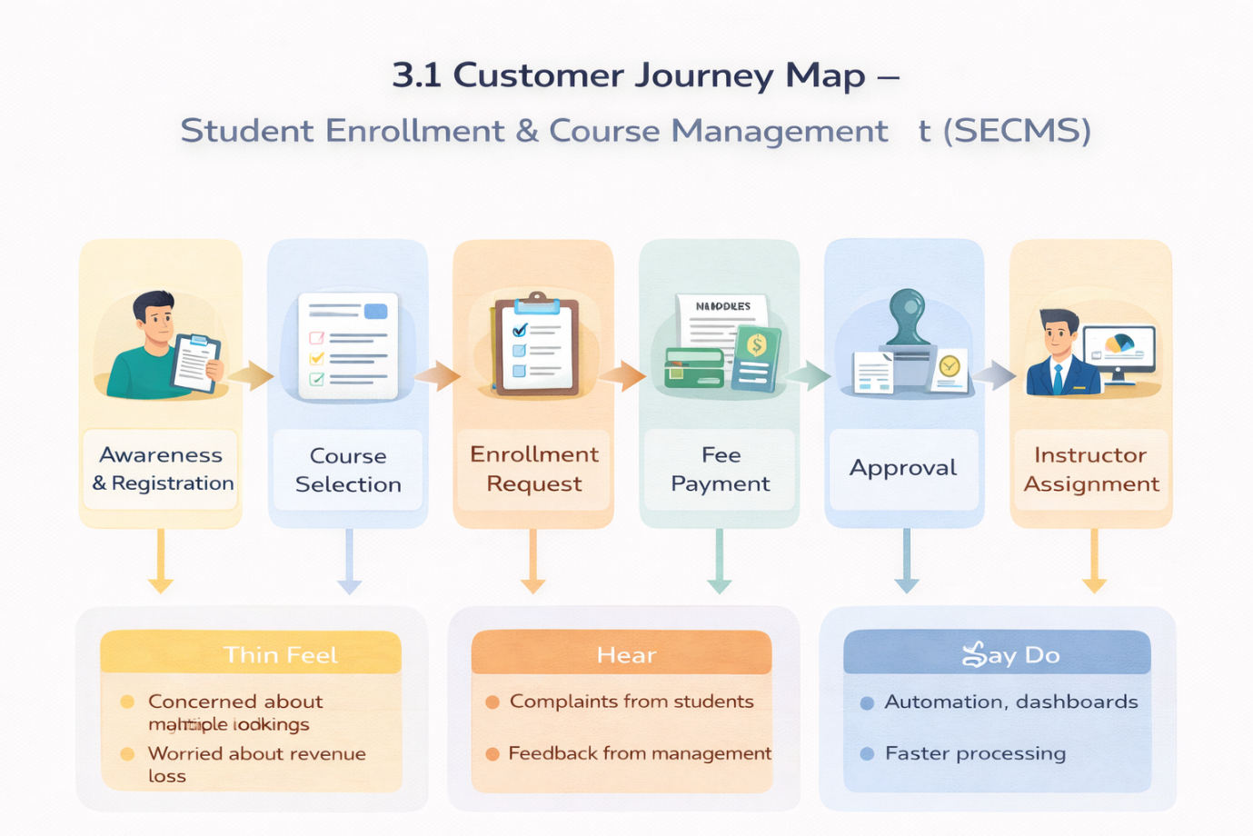

3.2 Solution Requirements
Functional Requirements
FR-1: Student Management
- Description: Manage student records.
- Details: Create, update, and view student profiles with contact details, admission status, and enrollment history. Validation rules prevent duplicate and incomplete records.
FR-2: Course Management
- Description: Create and manage courses.
- Details: Maintain course name, code, duration, fee, capacity, schedule, and status. Seat availability updates automatically as students enroll.
FR-3: Enrollment Processing
- Description: Request, approve, and reject enrollments.
- Details: Students or enrollment officers submit enrollment requests, which move through a multi-level Approval Process. Validation rules block duplicate and over-capacity enrollments, and notifications keep everyone informed of the status.
FR-4: Instructor Assignment
- Description: Auto-assign instructors.
- Details: A Flow assigns an available instructor to a course once enrollment is approved, and creates follow-up tasks for the instructor and enrollment officer.
FR-5: Reporting
- Description: Dashboards and reports.
- Details: Track enrollment volume, revenue collected, student status distribution, instructor workload, and pending approvals in real time.

Non-Functional Requirements
NFR-1: Security
- Description: Protect student and payment data.
- Details: Profiles, roles, and permission sets give each user access only to the information they need.
NFR-2: Usability
- Description: Simple and consistent user experience.
- Details: Clean Lightning App pages, page layouts, and record views that officers and instructors can use with minimal training.
NFR-3: Performance
- Description: Fast processing of enrollment operations.
- Details: Records, approvals, and reports load quickly, even during peak enrollment periods.
NFR-4: Scalability
- Description: Support growth in students and courses.
- Details: The cloud platform handles increasing data volume and users without redesign.
NFR-5: Reliability and Availability
- Description: Dependable access to the system.
- Details: The Salesforce cloud platform provides high uptime and automatic data backup.
NFR-6: Data Accuracy
- Description: Consistent and correct data.
- Details: Validation rules, required fields, and automation reduce manual errors.

3.3 Data Flow Diagram
This is the Level-1 data flow diagram for the four steps you listed.

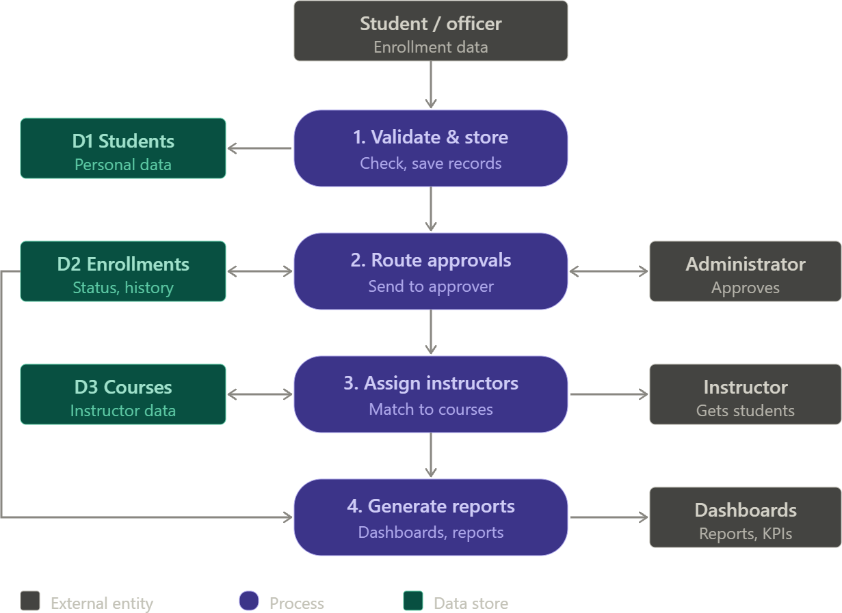

Here is how the diagram maps to your four steps:
- Step 1, input: The student or enrollment officer submits student and enrollment data into process 1.
- Step 2, validation and storage: Process 1 checks the data and saves it to D1 (student records). Process 2 keeps enrollment status in D2.
- Step 3, approval routing: Process 2 sends each request to the administrator and receives the decision back. It then updates the enrollment status in D2.
- Instructor assignment: Process 3 matches approved enrollments to courses using D3 and sends the student list to the instructor.
- Step 4, reports and dashboards: Process 4 reads the processed enrollment data from D2 and feeds the dashboards and reports.
4. PROJECT DESIGN PHASE

4.1 Problem–Solution Fit

SECMS directly addresses fragmented enrollment workflows by aligning user behavior, constraints, and automation using Salesforce-native capabilities.
Problem Statement
Educational institutions often manage student registration, course enrollment, approvals, and instructor allocation through separate spreadsheets, emails, and paper forms. This causes duplicate records, delayed approvals, unclear enrollment status, and no single view of institutional data. Enrollment officers spend time on manual checking, administrators lack visibility, and students are left waiting for updates.
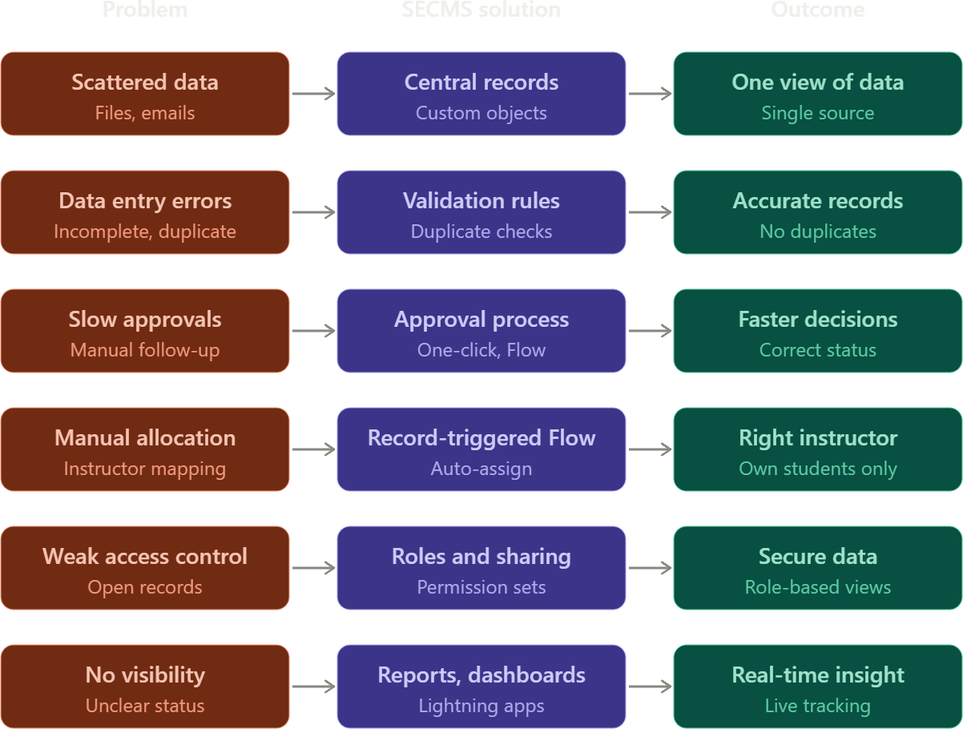
4.2 Proposed Solution
Functional Requirements
Parameter | Description
Problem | Enrollment is handled manually through spreadsheets, emails, and paper forms. This leads to duplicate records, delayed approvals, and unclear status.
Solution | SECMS, a Salesforce-based system that manages student registration, course enrollment, approvals, instructor assignment, and reporting on one platform.
Novelty
  End-to-end automation: validation, approval routing, instructor assignment, and status updates run without manual intervention, using Salesforce-native tools (Flows, Approval Processes, Lightning).
Revenue Model | Institutional deployment: colleges and universities adopt SECMS through licensing, implementation, and support.
4.3 Solution Architecture
The architecture integrates Salesforce objects, automation flows, approval processes, dashboards, and security layers. Users interact through the Lightning interface, automation processes their requests, and the results are stored in custom objects. A security layer controls access at every level.
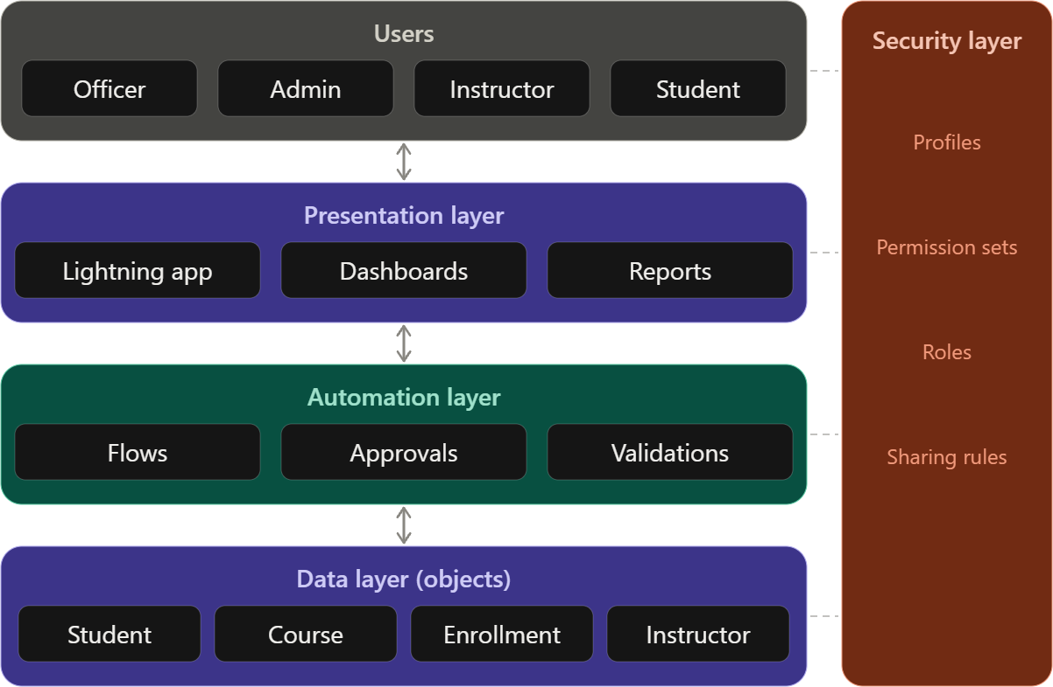

Here is how the layers work together:
- Users: Officers, admins, instructors, and students each get a role-specific view.
- Presentation layer: The Lightning app, dashboards, and reports give users a simple interface.
- Automation layer: Flows, approval processes, and validation rules handle checking, routing, and assignment.
- Data layer: The Student, Course, Enrollment, and Instructor objects hold all records and their relationships.
- Security layer: Profiles, permission sets, roles, and sharing rules apply at every layer, so users see only the records they are allowed to.

5. PROJECT PLANNING & SCHEDULING
5.1 Project Planning
The project follows the Agile methodology. Work is organized as Epics → User Stories → Story Points and delivered in sprints. Velocity from completed sprints is used to estimate the remaining work.

4.1 Problem–Solution Mapping
Problem (User Behavior / Constraint) | SECMS Solution | Salesforce-Native Capability
Student data scattered across files and emails | Centralized student and enrollment records | Custom objects (Student, Course, Enrollment) with relationships
Incorrect or incomplete data entry | Data checked at the point of entry | Validation rules and required fields
Duplicate students or course registrations | Duplicate enrollments blocked automatically | Duplicate rules and unique-key logic
Slow, manual approval of enrollments | Requests routed to the right approver, with one-click approve or reject | Approval Processes and Flow automation
Manual instructor allocation | Instructors assigned automatically based on course rules | Record-triggered Flows
Unauthorized access to sensitive records | Users see only what their role permits | Profiles, permission sets, roles, and sharing rules
No visibility into enrollment progress | Real-time status tracking and management reporting | Reports and Dashboards
Different needs for each user type | Role-based interfaces for officers, admins, instructors, and students | Lightning App pages and Lightning record pages

4.2 Functional Requirements
Problem (User Behavior / Constraint) | SECMS Solution | Salesforce-Native Capability
Student data scattered across files and emails | Centralized student and enrollment records | Custom objects (Student, Course, Enrollment) with relationships
Incorrect or incomplete data entry | Data checked at the point of entry | Validation rules and required fields
Duplicate students or course registrations | Duplicate enrollments blocked automatically | Duplicate rules and unique-key logic
Slow, manual approval of enrollments | Requests routed to the right approver, with one-click approve or reject | Approval Processes and Flow automation
Manual instructor allocation | Instructors assigned automatically based on course rules | Record-triggered Flows
Unauthorized access to sensitive records | Users see only what their role permits | Profiles, permission sets, roles, and sharing rules
No visibility into enrollment progress | Real-time status tracking and management reporting | Reports and Dashboards
Different needs for each user type | Role-based interfaces for officers, admins, instructors, and students | Lightning App pages and Lightning record pages

4.2 Functional Requirements
Parameter | Description
Problem | Manual enrollment handling through spreadsheets, emails, and paper forms, leading to duplicate records, delayed approvals, and unclear status.
Solution | Salesforce-based SECMS managing registration, enrollment, approvals, instructor assignment, and reporting on one platform.
Novelty | End-to-end automation of validation, approval routing, instructor assignment, and status updates using Salesforce-native tools.
Social Impact | Improved student experience through faster approvals, accurate status, and less administrative delay.
Revenue Model | Institutional deployment: licensing, implementation, and support for colleges and universities.
Scalability | Multi-department support; new departments, courses, and users can be added without redesign.

5.1 Product Backlog and Sprint Schedule
Sprint | Functional Requirement (Epic) | User Story Number | User Story / Task | Story Points | Priority | Team Members
Sprint-1 | Developer Setup | USN-1 | As a system administrator, I want to create a Salesforce developer account so that I can configure and deploy the Student Enrollment system. | 1 | High | Member1
Sprint-1 | Data Modeling | USN-2 | As an admin, I want to create custom objects for Student, Course, Enrollment, and Instructor so that academic data can be stored and managed efficiently. | 3 | High | Member2
Sprint-2 | Data Modeling | USN-3 | As a user, I want dedicated tabs for each object so that I can easily navigate between students, courses, enrollments, and instructors. | 3 | High | Member3
Sprint-2 | Data Modeling | USN-4 | As an admin, I want to create relevant fields such as student details, course information, and enrollment status so that complete records can be captured accurately. | 5 | High | Member4
Sprint-2 | Data Modeling | USN-5 | As an enrollment officer, I want a centralized Lightning App so that I can access all academic operations from one interface. | 3 | High | Member4
Sprint-2 | Data Modeling | USN-6 | As an admin, I want to define relationships between students, courses, and enrollments so that the system can logically link and track academic activities. | 5 | Medium | Member1
Sprint-2 | Data Modeling | USN-7 | As a user, I want customized page layouts so that only relevant information is displayed, improving clarity and ease of data entry. | 5 | High | Member2
Sprint-3 | Automation | USN-8 | As a system, I want to validate input data such as mandatory fields and enrollment limits so that incorrect or incomplete records are prevented. | 3 | High | Member4
Sprint-3 | Automation | USN-9 | As a system, I want automated flows to handle enrollment processing and notifications so that manual effort is reduced and processes become faster. | 3 | High | Member4
Sprint-3 | Automation | USN-10 | As an administrator, I want an approval process for enrollment requests so that registrations are verified before confirmation. | 5 | High | Member1
Sprint-4 | Security | USN-11 | As an admin, I want to configure role-based security so that users can only access data relevant to their responsibilities. | 5 | High | Member2
Sprint-5 | Reports | USN-12 | As a manager, I want reports on student enrollments, course registrations, and instructor assignments so that I can monitor academic operations. | 4 | High | Member3
Sprint-6 | Dashboards | USN-13 | As a manager, I want visual dashboards showing enrollment statistics and trends so that I can quickly analyze system performance. | 4 | Medium | Member4

Epic Summary
Epic | Stories | Story Points
Developer Setup | USN-1 | 1
Data Modeling | USN-2 to USN-7 | 24
Automation | USN-8 to USN-10 | 11
Security | USN-11 | 5
Reports | USN-12 | 4
Dashboards | USN-13 | 4
Total | 13 stories | 49

Sprint Schedule
Sprint | Total Story Points | Duration | Sprint Start Date | Sprint End Date (Planned) | Story Points Completed | Sprint Release Date
Sprint-1 | 4 | 7 days | 5 Oct 2026 | 11 Oct 2026 | 4 | 11 Oct 2026
Sprint-2 | 21 | 7 days | 12 Oct 2026 | 18 Oct 2026 | 21 | 18 Oct 2026
Sprint-3 | 11 | 7 days | 19 Oct 2026 | 25 Oct 2026 | 11 | 25 Oct 2026
Sprint-4 | 5 | 7 days | 26 Oct 2026 | 1 Nov 2026 | 5 | 1 Nov 2026
Sprint-5 | 4 | 7 days | 2 Nov 2026 | 8 Nov 2026 | 4 | 8 Nov 2026
Sprint-6 | 4 | 7 days | 9 Nov 2026 | 15 Nov 2026 | 4 | 15 Nov 2026
Total | 49 | 42 days |  |  | 49

Team Workload
Member | Stories | Total Story Points
Member1 | USN-1, USN-6, USN-10 | 11
Member2 | USN-2, USN-7, USN-11 | 13
Member3 | USN-3, USN-12 | 7
Member4 | USN-4, USN-5, USN-8, USN-9, USN-13 | 18

6. Project Development Phase
Milestone 1: Salesforce Developer Account Creation
Definition: A free Salesforce Developer Edition org is the working environment where the whole SECMS solution is built, tested and demonstrated. It gives full access to the platform without affecting any production system.
Key steps:
- Sign up at developer.salesforce.com/signup
- Verify the email and set a password
- Log in and open Setup

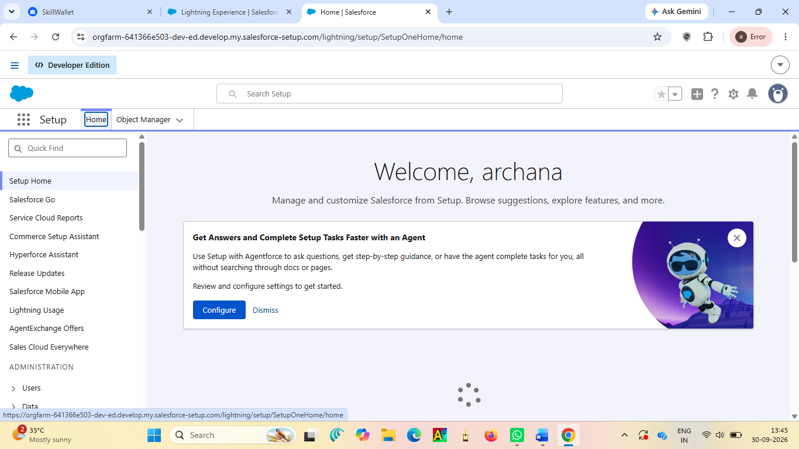

Milestone 2: Custom Object Creation (Student, Course, Enrollment, Instructor)
Definition: A custom object is a database table in Salesforce. Four objects store the core academic data: Student, Course, Enrollment (the link between a student and a course) and Instructor.
Key steps:
- Setup > Object Manager > Create > Custom Object
- Enter label, plural label and record name (Auto Number for Enrollment)
- Tick Allow Reports, Allow Search and Launch New Custom Tab Wizard

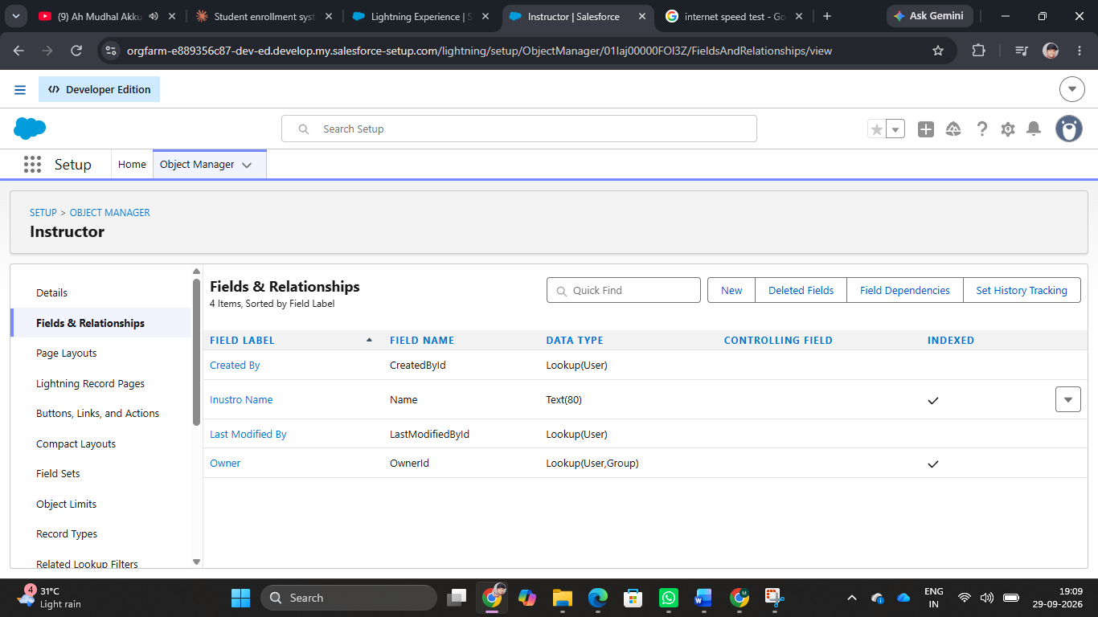

Milestone 3: Tabs Creation
Definition: A tab is a navigation shortcut that opens an object's list of records. Dedicated tabs let users move quickly between students, courses, enrollments and instructors.
Key steps:
- Setup > Tabs > Custom Object Tabs > New
- Select the object and choose a tab style
- Set visibility for profiles and add the tab to apps

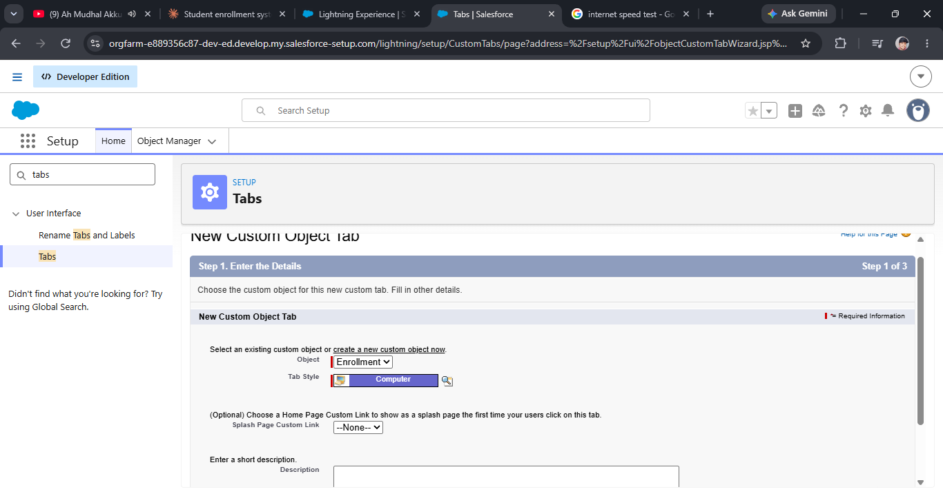

Milestone 4: Lightning App Creation
Definition: A Lightning App groups tabs and utilities into one branded workspace. The SECMS app gives enrollment officers a single interface for all academic operations.
Key steps:
- Setup > App Manager > New Lightning App
- Set name, branding and navigation style
- Add the four object tabs, Reports and Dashboards
- Assign the app to user profiles
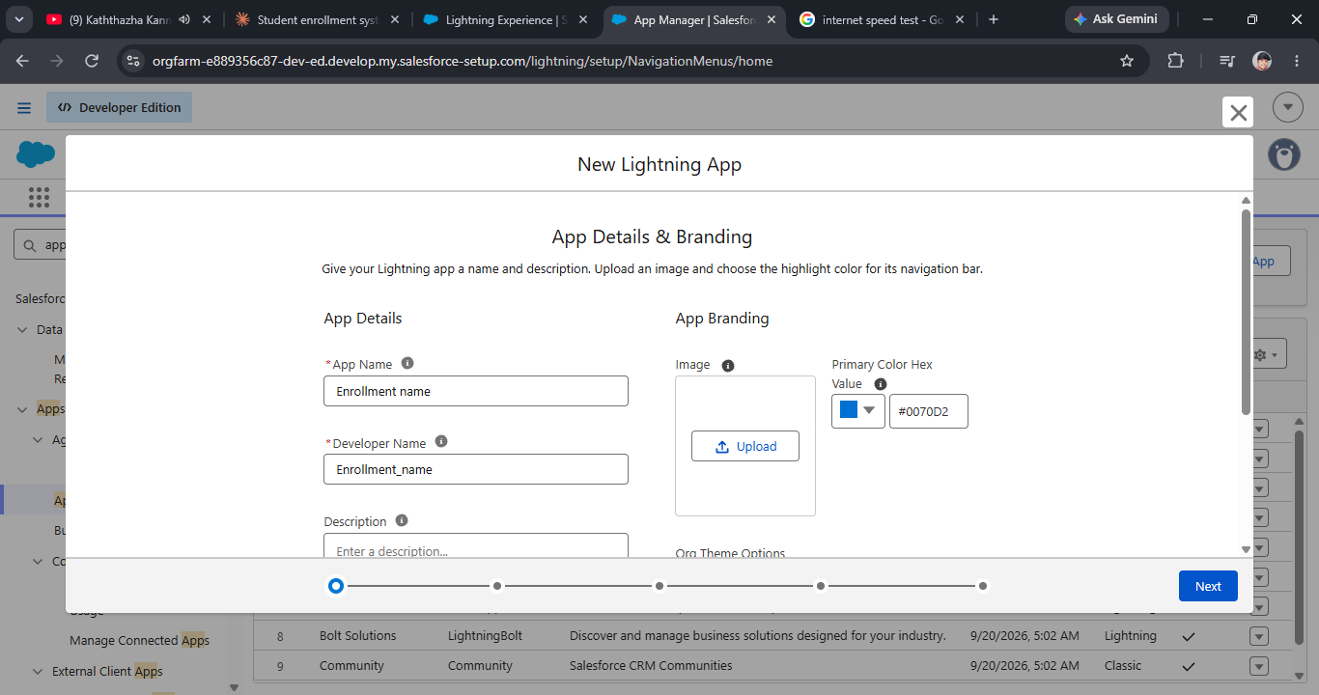

Milestone 5: Fields Creation
Definition: Fields are the columns of an object, and each holds one piece of data. They capture student details, course information and enrollment status accurately.
Key steps:
- Object Manager > (object) > Fields & Relationships > New
- Choose the data type (Text, Email, Date, Picklist, Number)
- Set field name, required flag and picklist values such as Pending, Approved, Rejected
- Set field-level security and add to layouts
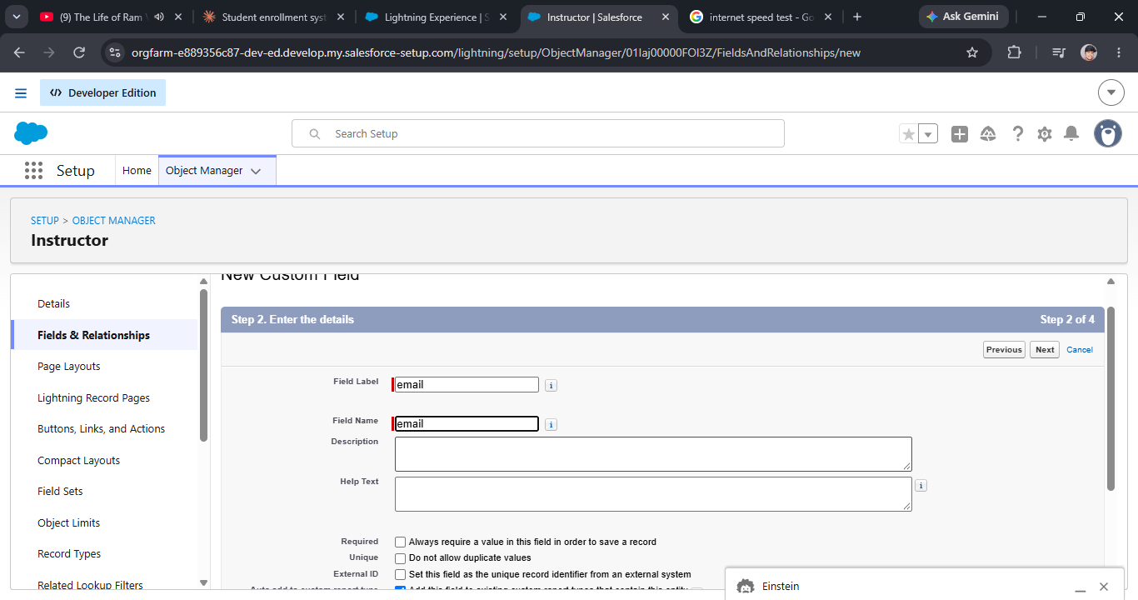

Milestone 6: Create Relationships
Definition: Relationships link records across objects. A Lookup or Master-Detail field connects Enrollment to both Student and Course so that activity can be tracked and rolled up.
Key steps:
- Create a Master-Detail or Lookup field on Enrollment referencing Student
- Create a second relationship field referencing Course
- Optionally relate Instructor to Course
- Check the related lists on parent records

Milestone 7: Page Layout Customization
Definition: A page layout controls which fields, sections and related lists appear on a record page. Customizing it keeps screens clean and makes data entry easier.
Key steps:
- Object Manager > (object) > Page Layouts
- Drag fields into logical sections and mark key fields required
- Add related lists and buttons
- Assign layouts to profiles

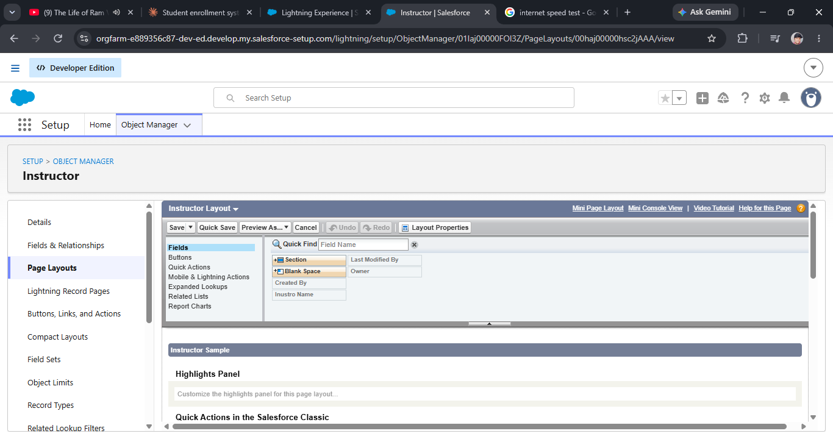
Milestone 8: Validation Rules
Definition: A validation rule is a formula that blocks a record from being saved when data is wrong or incomplete, for example a missing mandatory field or an enrollment above the course limit. Duplicate rules can also prevent repeated enrollments.
Key steps:
- Object Manager > (object) > Validation Rules > New
- Write the error condition formula
- Enter the error message and choose where it appears
- Activate and test with invalid data
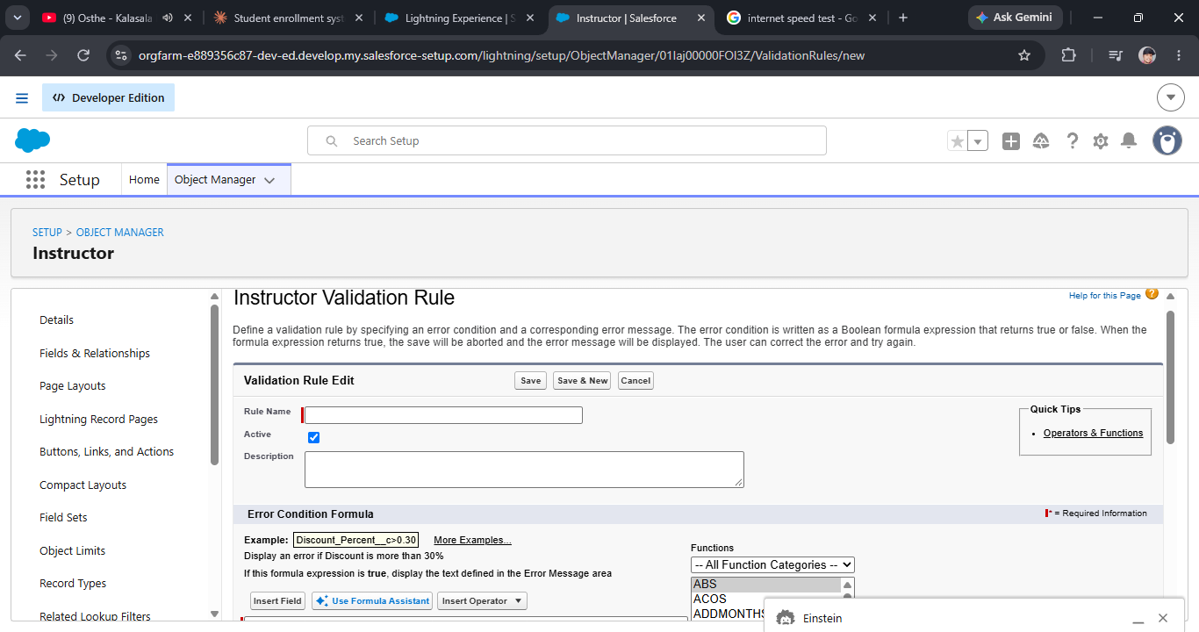
Milestone 9: Flows (Automation)
Definition: Flow is Salesforce's declarative automation tool. Record-triggered flows process enrollments, send notifications and can assign instructors automatically, replacing manual work.
Key steps:
- Setup > Flows > New Flow > Record-Triggered Flow
- Choose the object (Enrollment) and trigger condition
- Add decision, update and email-alert elements
- Save, activate and test

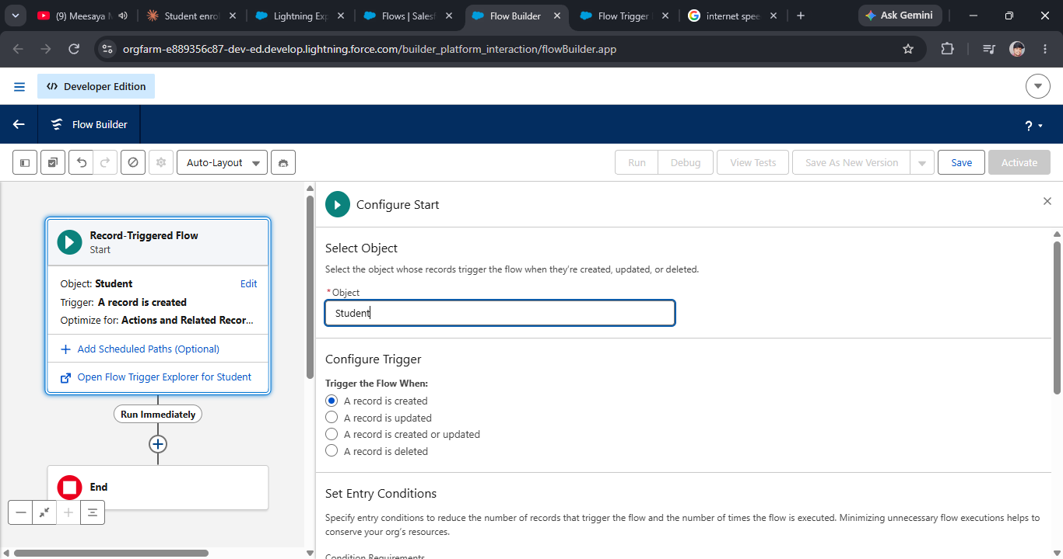

Milestone 10: Approval Process
Definition: An approval process routes a record to the right approver, who can approve or reject it with one click. Enrollment requests are verified before they are confirmed.
Key steps:
- Setup > Approval Processes > Enrollment > Create New
- Set entry criteria and approver (user, role or queue)
- Define approval and rejection actions, such as updating status
- Activate the process
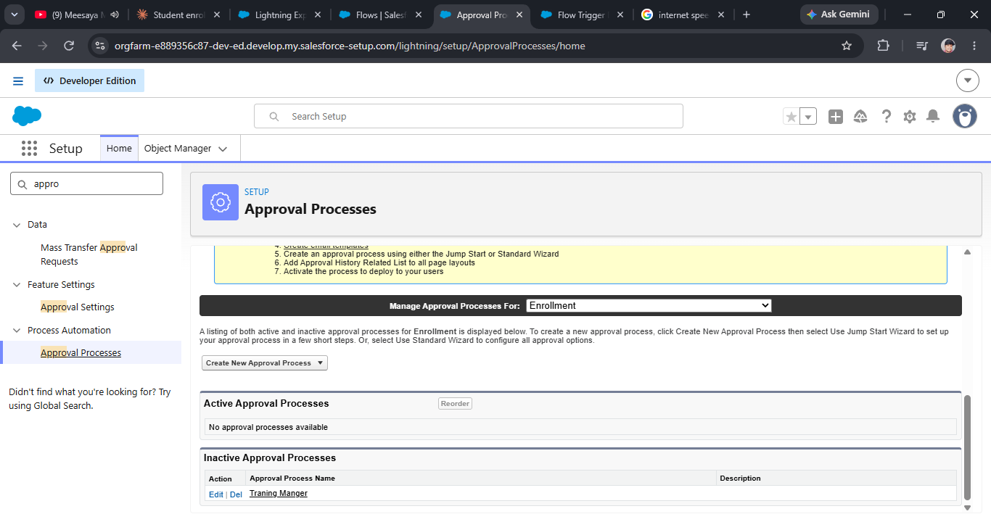

Milestone 11: Reports
Definition: Reports are saved queries that list records by criteria and grouping. Managers use them to monitor enrollments, course registrations and instructor assignments.
Key steps:
- Reports > New Report
- Select a report type such as Enrollments with Students and Courses
- Add filters, grouping and columns
- Save into a folder
Milestone 12: Dashboards
Definition: Dashboards display report data as charts, gauges and tables. They give managers a real-time view of enrollment statistics and trends.
Key steps:
- Dashboards > New Dashboard
- Add components from saved reports
- Choose chart types and set titles
- Save and set the running user

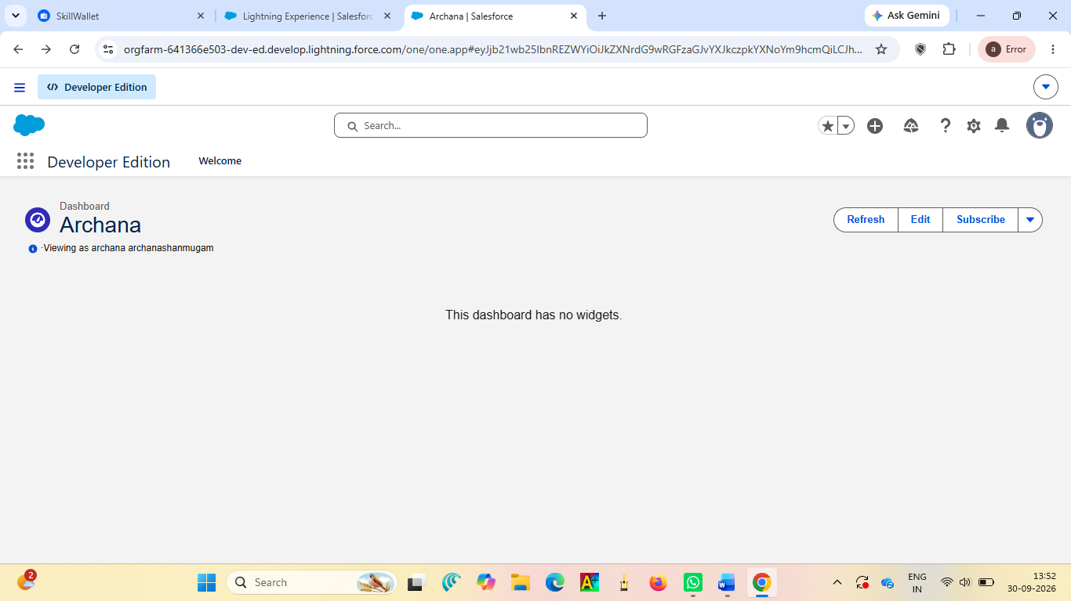

Milestone 13: Security Setup
Definition: Security controls who can see and edit what. Roles, profiles, permission sets and sharing rules ensure users only access data relevant to their responsibilities.
Key steps:
- Create roles (Admin, Officer, Instructor, Student) in the role hierarchy
- Configure profiles and permission sets for object and field access
- Set organization-wide defaults and sharing rules
- Test using Login As

Milestone 14: Conclusion

Project Summary
SECMS (the Salesforce-based enrollment and course management system) replaces the spreadsheets, email threads and paper forms that previously held the process together. It brings enrollment, approvals, instructor assignment and reporting into one Salesforce platform, so everyone works from a single source of truth.

Outcomes and Benefits
- Efficiency: Less manual data entry, chasing of approvals and reconciling of versions.
- Accuracy: Validation reduces duplicate, missing and inconsistent records.
- Speed: Automated approvals and assignments shorten turnaround times.
- Transparency: Stakeholders see current status through dashboards instead of asking for updates.
- Accountability: Every record, approval and change is traceable in one system.
- Scalability and maintainability: Because it uses standard Salesforce functionality rather than heavy custom code, new departments can be onboarded through configuration, and administrators can maintain it without specialist developers.
Possible Future Enhancements
- Student portal (for example, an Experience Cloud site) for self-service enrollment, status tracking and document uploads
- Mobile access through the Salesforce mobile app or a tailored mobile experience for staff and instructors
- Automated notifications by email or SMS for approvals, schedule changes and deadlines
- Advanced analytics such as enrollment forecasting, capacity planning and trend reporting
- Integrations with an LMS, student information system, payment gateway or calendar tools
- Expansion to additional departments using the existing framework
- AI-assisted features, such as smarter instructor matching or flagging enrollment bottlenecks
Closing Statement
SECMS delivers on its core objectives: one platform, cleaner data, faster approvals, automated assignments and live reporting. Its native, configuration-first design gives the organization a solid foundation to grow from.

